**Software Document:**

**Quick Guide**

**Helio ModBus Configurator v1.0**

|  |  |  |  |
| --- | --- | --- | --- |
|  | **Name** | **Date** | **State** |
| **First Release** | **Leonardo Billi** | 05/05/2017 | Done |
| **Review** |  |  |  |

Index

1. Disclaimer 3

2. Requirements 3

3. Installation 3

4. Overview 3

5. “Parameters” Tab 4

5.1 Download Settings Procedure 5

5.2 Upload Settings Procedure 6

6. “Configuration” Tab 9

7. “Calibration” Tab 10

7.1 Calibration Procedure 11

8. “Settings” Tab 12

9. “Tools” Tab 13

10. Conclusions 14

# Disclaimer

“Helio Modbus Configurator”, provided by Heliocentris Italy, is supplied "AS IS" without any warranties and support.

Heliocentris Italy assumes no responsibility or liability for the use of the software..

Heliocentris Italy reserves the right to make changes in the software without notification. Heliocentris Italy also make no representation or warranty that such application will be suitable for the specified use without further testing or modification.

# Requirements

* Windows 7 or higher.
* The IP address of the PC must be in the same network of the electrolyzer. (The default ip address of the electrolyzers is 192.168.1.222)
* Default Modbus port 502 available.

# Installation

Launch the installer “MB_ConfigSetup.msi” and wait the accomplishment of the installation.

# Overview

The “Helio ModBus Configurator” software (short: “MB_Conf”) has the purpose to allow the Heliocentris Italy’s customers in the configuration of the electrolyzer systems (calibrations, configuration code, etc.), and also perform a first troubleshooting.

# “Parameters” Tab

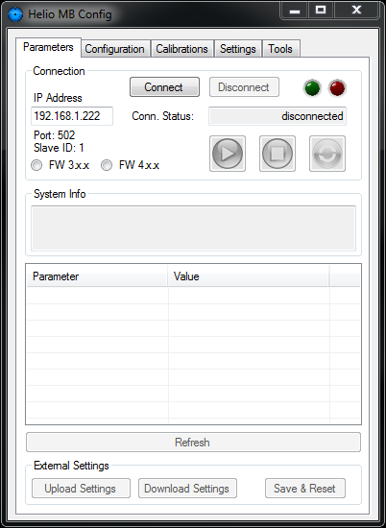

**Tab selector**: here you can switch between the different functions of the software to configure the EL.

**Connection**: here you can manage the Modbus connection with the EL. You have to put the IP address of the EL and choose the firmware branch version. Then, by pressing the “*Connect*” button, the software will initialize the Modbus connection with the device

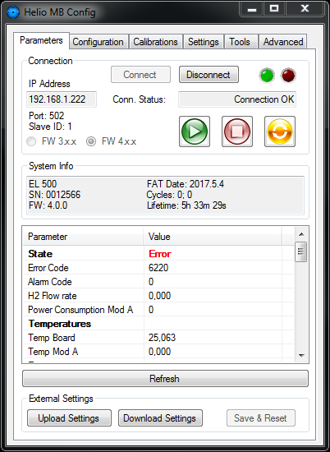

**System Info**: here there are some information about the device: the model, the serial number, the firmware version, the date of the factory acceptance test, the number of production cycles and the lifetime of the system.

**Electrolyzer Commands**: here you can Start and Stop the hydrogen production and send the “Software reset” command.

**System Status**: here there are some information about the status of the device. For example, the state of the state machine, error and alarm information, temperatures, pressures, voltages, currents, and so on.

With the “*Refresh*” button you update the values in the system status grid.



**External Settings**: here you can download and upload the configuration of the device to backup and restore the electrolyser’s settings.

## Download Settings Procedure

Pressing the button “*Download Settings*” you can start the procedure to create a backup file of the configuration of yours electrolyzer.

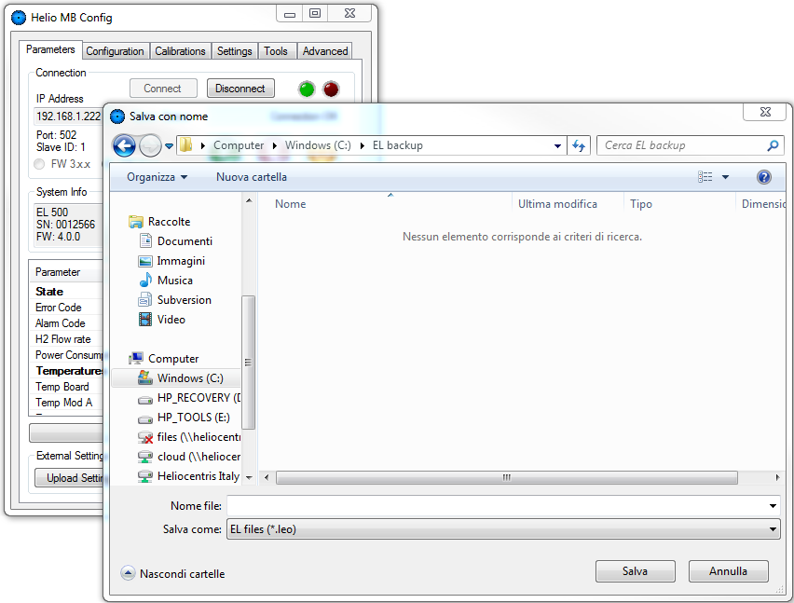You have to choose a destination folder and a name for your backup:

Then the backup procedure starts.

A message will inform you when the procedure is completed:

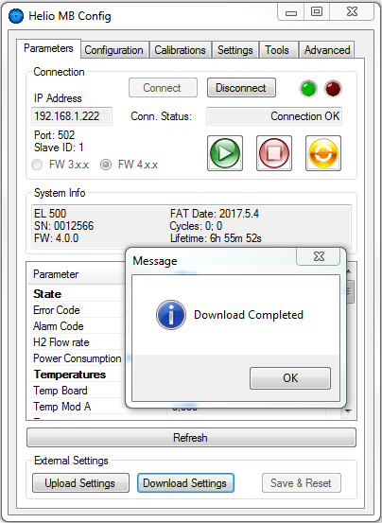It is better to perform the backup procedure when the electrolyzer is not producing hydrogen.

## Upload Settings Procedure

Pressing the button “*Upload Settings*” you can start the procedure to restore a backup file on yours electrolyzer.

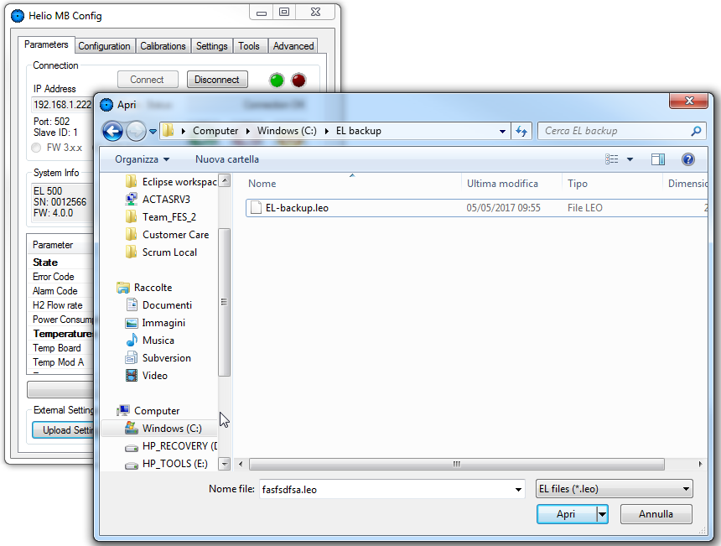Select the backup file:

The restore procedure starts.

A message will inform you when the procedure is completed:

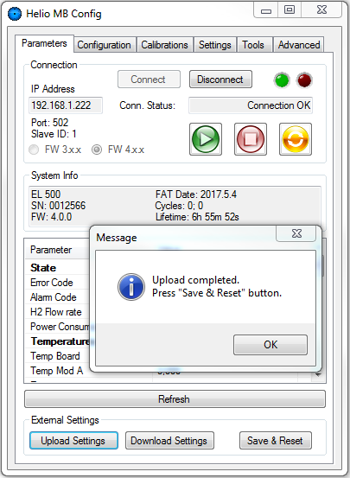

At this point the button “Save & Reset” became available. Press it to save the uploaded configuration in the electrolyzer.

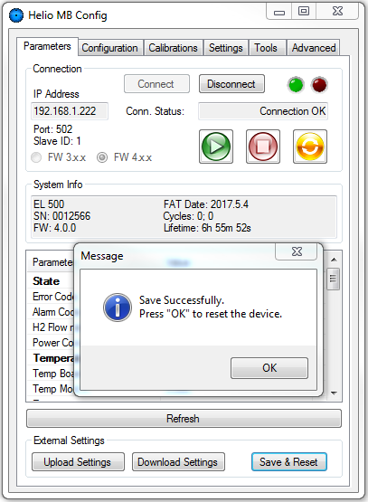A new message will inform you that the new data are correctly saved in the device.

Press “*OK*” to reset the electrolyzer.

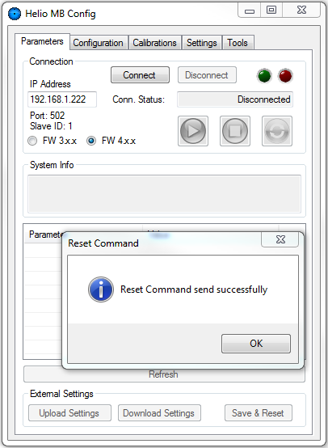

# “Configuration” Tab

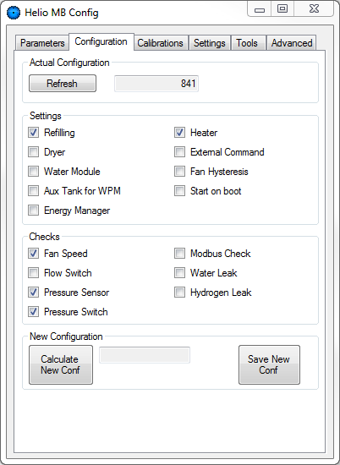

**Actual Configuration**: the actual configuration code of the device.

**Settings**: the options and configurations related to the actual configuration code.

Here it is possible to enable and disable the settings of the electrolyzer.

**New Configuration**: After the selection of the desired settings of the device, pressing the button “*Calculate New Conf*”, you will calculate the new configuration code of the system. Then, you can save it using the button “*Save New Conf*”.

**The new configuration will be available only after the reset of the electrolyzer!**

In this tab it is possible to decode the configuration code of the electrolyzer.

It possible to use this decoding functionality also without Modbus communication with the EL.

# “Calibration” Tab

In this section of the software it is possible to modify the calibration values of various sensors installed in the electrolyzer.

**Sensor selector**: here you can select the sensor for which you want to perform a new calibration

**Load Calibration Values**: pressing the button “*Load Calibration Values*”, the software will download from the electrolyzer the actual calibration values for the previously selected sensor.

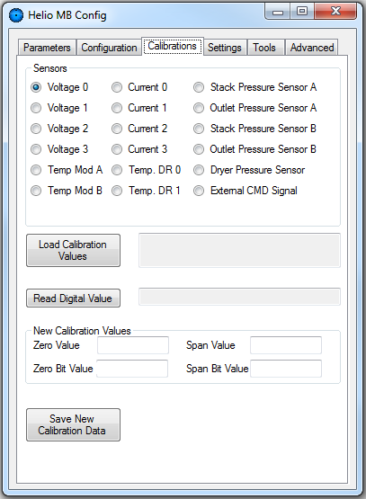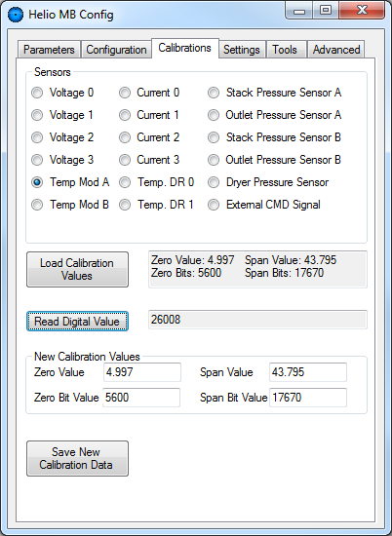

**Calibration Values**: pressing the button “*Load Calibration Values*” the software will download from the electrolyzer the actual calibration values for the previously selected sensor.

Zero Value: physical value of the first point (e.g. °C, V, A, bar).

Zero Bits: digital value corresponding to the Zero Value (bits).

Span Value: physical value of the second point used for the caliubration (°C,V, etc.)

Span Bits: digital value corresponding to the Span Value (bits).

**Read Digital Value**: pressing the button “*Read Digital Values*”, the software will download from the electrolyzer the bit representation of the actual physical value read by the selected sensor.

**Digital Value**: pressing the button “*Load Calibration Values*” the software will download from the electrolyzer the actual calibration values for the previously selected sensor.

**New Calibration Values**: here you have to place the new calibration values that will be saved in the electrolyzer after the pressing of the button “*Save New Calibration Data*”.

## Calibration Procedure

To calibrate a sensor the system need two different physical values: the “Zero Value” and the “Span Value”.

In the last screenshot in the previous page we have, for the Temperature sensor of the Module A, the first physical point at 5°C and the second one at 43.8°C. The corresponding bits values are respectively: 5600 and 17670 bits.

In order to change the calibration values, you need an external calibrated sensor to measure the physical values.

Take a first value (the Zero Value) and read the corresponding digital value by using the “*Read Digital Value*” button. Write these numbers in the “New Calibration Values” section in the boxes related to the Zero Values. A good choice for the Zero data is a not operating condition (e.g. ambient temperature for the temperatures, a not producing stack for voltages and currents, the ambient pressure for the pressure sensors, etc.).

Take a second value preferably far from the first one and read the corresponding digital value. Then, write these numbers in the “New Calibration Values” section in the boxes related to the Span data. A good second point is in operative condition (e.g. 45°C for the temperatures, a fulfilled cylinder for the pressures, etc.).

When you are done, press the “Save New Calibration Data” button and reset the system.

# “Settings” Tab

**Pressure Thresholds**: here you can set the pressure threshold to stop hydrogen production, and also the pressure value for which the system will restart automatically the production.

**Network Settings**: here you can set the IP address of the EL.

You have to reset the device to use the new IP address.

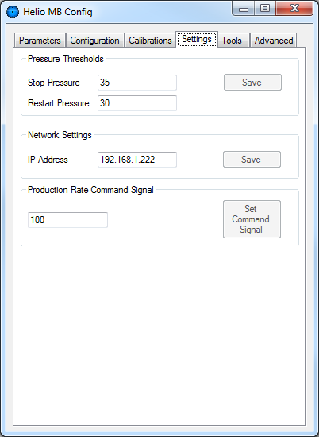

**Production Rate Command Signal**: in case of electrolyzer with an external command signal to modulate the production rate, you can set here the desired production rate.

# “Tools” Tab

In this tab you can find some utilities related to the interpretation of the error codes.

**Error Code Interpreter**: in case of multiple simultaneous errors, here you can decode the error code and see where is the issue.

**Alarm Code Interpreter**: in case of multiple simultaneous alarms, here you can decode the alarm code and see where is the issue.

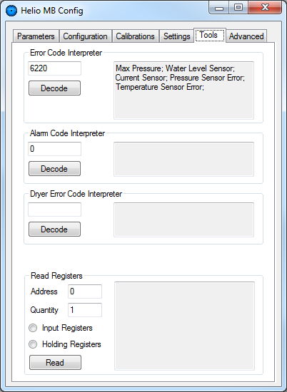

**Dryer Error Code Interpreter**: in case of the general “Dryer Error” message, here you can found detailed information about the dryer issue.

**Read Registers**: a simple framework to read Modbus registers.

You should never have the need to use this feature.

# Conclusions

If you found a bug or you want to suggest an improvement or modification,

Please send me an email:

[leonardo.billi@heliocentris.com](mailto:leonardo.billi@heliocentris.com?subject=Bug/Suggestion:%20Helio%20MB%20Config)

Thank you!